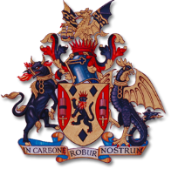

Worshipful Company of Fuellers visit to 152 (North Irish) Regiment RLC on Exercise Austere Crusader

Military Affiliates are an important element of livery life and our association with 152 (North Irish) Regiment RLC is no exception. With the Master and Clerk on Civic and Remembrance duties in the City it fell to the Master’s Consort and the Chairman of the Charitable Trust to accept 152’s invitation to join them on exercise at Kinloss Barracks, a former RAF station on the Moray Firth in the north of Scotland. Now home to 39 Engineer Regiment, it used to be the main base for the RAF's fleet of Nimrod MR2 maritime patrol aircraft.
Austere Crusader, a theatre and port enablement exercise in October/November has tested the Army’s ability to open a port from scratch, blending all things Army maritime, diving, ship to shore fuel, engineering, and logistics. 152’s specific role was to establish, maintain, and decommission a Primary Bulk Fuel Installation, and to transport and distribute bulk fuel across the exercise.
Also invited by 152 were civilian employers of some of the soldiers from 152. As a reserve regiment, most of their soldiers have other full-time jobs. We met up with this friendly group of employers and were hosted to an excellent curry by Lieutenant Colonel Colin Sykes and Major Robert Clements and then retired to our rooms at the Officers’ Mess at Kinloss Barracks.

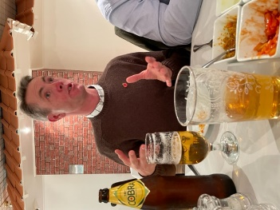 | The Master’s Consort explaining the finer points of his relevant tanker driver experience!

After a minor hiccup with ground transportation, namely the realisation that Major Clements had in fact tried to steal a Peugeot with the key from a Vauxhall, a hearty breakfast was shared at the Sergeants’ Mess before we arrived at the Command Centre for a briefing about the Regiment from the CO, and about the exercise by Major Mark Livingstone. Information given and received, along with a cup of tea, we were then driven to the exercise area on the far side of the base (which occupies some 666 hectares).

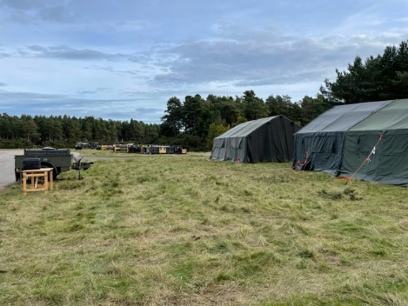  Life under canvas | 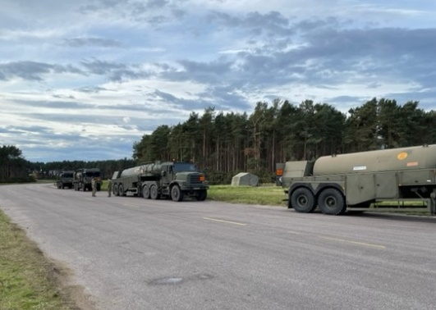  Collective noun for several tankers?

After a quick introduction at the tented camp, we went for an up close and personal look at a Close Support Tanker (capacity 20,000 litres) before we went for a trip round the airfield aboard a Unit Support Tanker (capacity 7,000 litres) with a chatty and informative lady driver! Both vehicles are six-wheeled, the CST being articulated, and have great off-road ability with adjustable suspension and tyre pressure to account for different terrains and weather conditions.

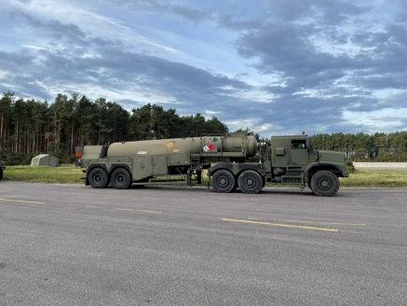 | 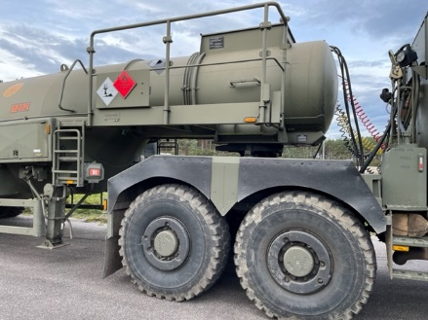
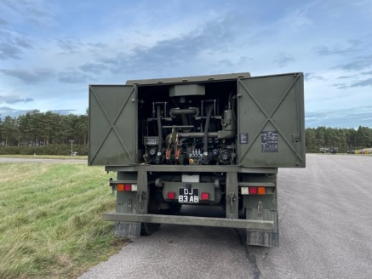 | 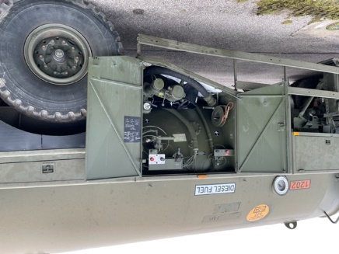
Various views of a CST
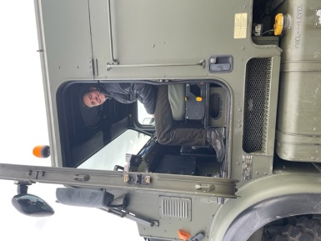 | 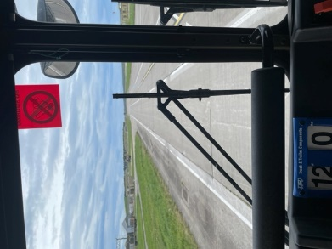
Please can I have one? Top speed 51 mph!
Having handed in our mobile phones (safety first), we were escorted to the PET area which encompassed the control point and laboratory testing tent, where they physically test the quality of the fuel both in and out of the tankers and storage facility. It transpires this is a splendid place to work, because due to the testing regime the tent is always warm and heat for a quick brew is readily available!

A quick stroll down to the Primary Bulk Fuel Installation; a Royal Engineer constructed BUND surrounding the fuel storage area, capable of storing up to 300,000 litres of diesel to fuel 152’s own tankers and vehicles, and those from other units. A hydraulic generator drives a pump that can deliver up to 800 litres per minute. The overall capability of 152’s equipment is very impressive, offering superb operational flexibility in the field.
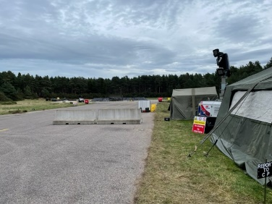 | 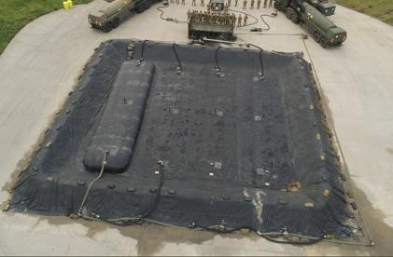
Bulk Fuel Installation – from the Control Tent and from above

Of course, an Army marches on its stomach, so as the Highland weather closed in, we were ushered into a tent, which had previously been lashed down and sand-bagged against the Scottish autumn and proceeded to cook our own lunch, using Army stoves and mess tins of hot water. Under the watchful eye of a Corporal with a Two Ronnies’ sense of humour, we sampled the Army’s newest “compo” rations and, you know what, they were jolly tasty, Dave consuming the chilli con carne and cinnamon cake (which added up to about 800 calories of the 3000 daily ration). Watch out Master, it sounds like a romantic Boil in the Bag dinner is on its way!
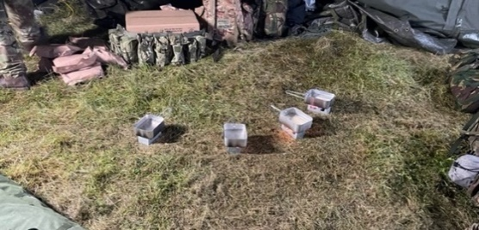
Masterchef? | Menu Choices

All too soon it was time to take our leave and head back to downtown Inverness to do our best to support the local economy.

Haggis Meat Balls! |  | Cullen Skink

A fantastic day, wonderful highly skilled soldiers taking pride in their work and revelling in taking the opportunity to demonstrate their skills – both interpersonal and technical.
Thank you 152 (North Irish) we had a fantastic time with you!

Dave Marsh, Master’s Consort &
Chloë Andrews-Jones, Chairman Fuellers Charitable Trust
November 2021

